Remember the days we **used to** share

Remember the time when I **was** there

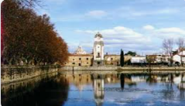I **believed** every single word you **said**

Just like a child, I **lost** my head

I didn't care if it was day or night

I just **wanted** to have you by my side

The moon went up, the sun **went** down

But you **were** still around

Alta Gracia, my love (4)

Remember how we **spent** the night

How we **kissed** and held each other tight?

Everything **was** like a beautiful dream

You **were** the sweetest woman I've ever seen

How **could** I know our love wouldn't stand a chance?

I **had to** go and end this wonderful romance

Now I'm so sad and blue here without you, what can I do?

I **used to** love her from the bottom of my heart

**Didn't** realize that time was slipping by

Now we're living oh so far apart

I give grace for the days that I **held** her by my side

By my side

Alta Gracia, my love 3

Alta Gracia, oh-oh